Name : Alveena Naz
Reg No. FA25-BSE-010
OOP Lab 5

Lab Task 1:
// main class
public class JavaApplication14 {
public static void main(String[] args) {
Address address = new Address(12,3,"Attock",2341);
Person per = new Person();
per.setName("Alveena");
per.setAddress(address);
per.display();

}

}
// address class
public class Address {
private int streetNumber;
private int houseNumber;
private String city;
private int code;
Address(){}
Address(int streetNum,int houseNum,String city,int code){
this.streetNumber = streetNum;
this.houseNumber= houseNum;
this.city=city;
this.code = code;
}
//setters
public void setStreet(int streetNum){
this.streetNumber = streetNum;
}
public void setHouse(int houseNum){
this.houseNumber= houseNum;
}
public void setCity(String city){
this.city=city;
}
public void setCode(int code){
this.code = code;
}
//getters
public int getStreet(){
return streetNumber;
}
public int getHouse(){
return houseNumber;
}
public String getCity(){
return city;
}
public int getCode(){
return code;
}
public void display(){
System.out.println("Address:");
System.out.println("House number: " + this.houseNumber + " Street number: " + this.streetNumber + " City: " + this.city + " Code:" + this.code);
}

}
//Person class
public class Person {
private String name;
private Address address;
Person(){}
Person(String name, Address add){
this.name = name;
this.address = add;
}
public void setName(String name){
this.name=name;
}
public void setAddress(Address add){
this.address = add;
}
public void display(){
System.out.println("name: " + name);
address.display();
}

}
OUTPUT:
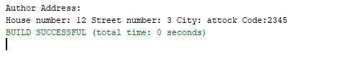
Lab task 2:
// main class
public class JavaApplication15 {
public static void main(String[] args) {
Address address = new Address();
address.setHouse(12);
address.setStreet(3);
address.setCity("attock");
address.setCode(2345);
Person author1 = new Person(address);
Book book = new Book("Sky runner","Salam Book Dipu",author1);
book.display();

}

}
//book class
public class Book {
String bookName;
String publisher;
Person person;
Book(){}
Book(String bookName,String publisher,Person per){
this.bookName = bookName;
this.publisher = publisher;
this.person= per;
}
public void display(){
System.out.println("Book name: " + bookName);
System.out.println("Publisher: " + publisher);
person.display();
}

}
//person class
public class Person {
private Address address;
Person(){}
Person( Address add){
this.address = add;
}
public void setAddress(Address add){
this.address = add;
}
public void display(){
address.display();
}

}
//address class
public class Address {
private int streetNumber;
private int houseNumber;
private String city;
private int code;
Address(){}
Address(int streetNum,int houseNum,String city,int code){
this.streetNumber = streetNum;
this.houseNumber= houseNum;
this.city=city;
this.code = code;
}
//setters
public void setStreet(int streetNum){
this.streetNumber = streetNum;
}
public void setHouse(int houseNum){
this.houseNumber= houseNum;
}
public void setCity(String city){
this.city=city;
}
public void setCode(int code){
this.code = code;
}
//getters
public int getStreet(){
return streetNumber;
}
public int getHouse(){
return houseNumber;
}
public String getCity(){
return city;
}
public int getCode(){
return code;
}
public void display(){
System.out.println("Author Address:");
System.out.println("House number: " + this.houseNumber + " Street number: " + this.streetNumber + " City: " + this.city + " Code:" + this.code);
}

}
OUTPUT:
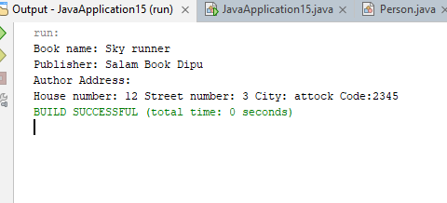

Lab Task 3:
//main class
public class JavaApplication16 {
public static void main(String[] args) {
Point p1 = new Point(2.3,4.5);
Point p2 = new Point(6.7,1.2);
Line line1 = new Line(p1,p2);
line1.findLength();
}

}
// point class
public class Point {
private double xCord;
private double yCord;
Point(){}
Point(double x , double y){
this.xCord = x;
this.yCord=y;
}
public void setX(double x){
this.xCord = x;
}
public void setY(double y){
this.yCord=y;
}
public double getX(){
return xCord;
}
public double getY(){
return yCord;
}
public void dislay(){
System.out.println("X cord: " + xCord + " Y Cord: " + yCord);
}
}

// Line class
public class Line {
Point startPoint;
Point endPoint;
Line(){}
Line(Point p1, Point p2){
this.startPoint = p1;
this.endPoint = p2;
}
public void findLength(){
System.out.println("Length of the line is " +(Math.sqrt((endPoint.getX() - startPoint.getX()) * 2 + (endPoint.getY() - startPoint.getY())* 2)));
}

}

OUTPUT:
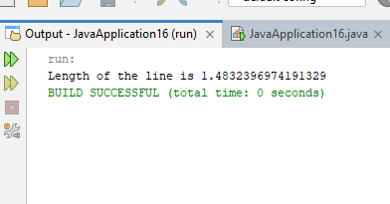

Lab Task 4:
//main
public class JavaApplication17 {
public static void main(String[] args) {
Pizza pizza1 = new Pizza("medium",2,3,1);
pizza1.getdescription();
Pizza pizza2 = new Pizza("Large",1,3,4);
pizza2.getdescription();
Pizza pizza3 = new Pizza("small",0,1,2);
pizza3.getdescription();
PizzaOrder pizzaorder = new PizzaOrder(pizza1,pizza2,pizza3);
pizzaorder.calTotal();
}

}
//pizza class
public class Pizza {
private String size;
private int cheese;
private int pepperoni;
private int ham;
Pizza(String sz, int cheese,int peppe,int ham){
this.size = sz;
this.cheese = cheese;
this.pepperoni = peppe;
this.ham = ham;
}
public void setSize(String sz){
this.size = sz;
}
public void setCheese(int cheese){
this.cheese = cheese;
}
public void setPepperoni(int peppe){
this.pepperoni = peppe;
}
public void setHam(int ham){
this.ham = ham;
}
// getters
public String getSize() {
return size;
}

public int getCheeseToppings() {
return cheese;
}

public int getPepperoniToppings() {
return pepperoni;
}

public int getHamToppings() {
return ham;
}
public double calCost(){
double cost =0;
int totalToppings = cheese + pepperoni + ham;
if(size.equalsIgnoreCase("small"))
cost = 10 + (2 * totalToppings);
else if(size.equalsIgnoreCase("medium"))
cost = 12 + (2 * totalToppings);
else if(size.equalsIgnoreCase("large"))
cost = 14 + (2 * totalToppings);

return cost;

}
public void getdescription(){
System.out.println("pizza size: " + size + "\nCheese toppings: " + cheese + "\npepperoni toppings: " + pepperoni + "\nHam toppings: " + ham);
}
}
//pizza order
public class PizzaOrder {
Pizza pizza1;
Pizza pizza2;
Pizza pizza3;
PizzaOrder(Pizza p1 , Pizza p2, Pizza p3){
this.pizza1=p1;
this.pizza2 = p2;
this.pizza3 = p3;
}
public double calTotal(){
double total =0;
if(pizza1!=null)
total+=pizza1.calCost();
if(pizza2!=null)
total+=pizza2.calCost();
if(pizza3!=null)
total+=pizza3.calCost();

return total;
}
}

OUTPUT:
